Tuesday 13th September 2022

Dear Parent/Students,

This is a letter to make you aware of the audition and show dates for ‘Aladdin’

Auditions will be held during student’s usual class times. Students will be required to sing the material on which they have been working on in class.
The times and dates are as follows:

Tuesday Juniors – Tuesday 27th September – 5.00pm-6.00pm
Wednesday Juniors – Wednesday 28th September – 6.30pm-7.30pm
Saturday A Juniors – Saturday 1st October – 10.30am – 11.30am
Saturday B Juniors – Saturday 1st October - September – 11.30am – 12.30pm

Any students who are unable to attend their class and want to audition must rearrange with their teacher before the audition date.
Please note students do not have to audition if they do not want to, however students can only be considered for principle roles if they have auditioned.
All students should still attend their lesson as the auditions will not take the entire hour.

Show Dates:
Tuesday and Wednesday Juniors
Thursday 2nd March – Dress rehearsal 5.00pm – 8.00pm (£5)
Friday 3rd March – Show – 7.00pm
Saturday 4th March – Show – 7.00pm
Sunday 5th March – Show – 2.00pm

Saturday A & B Juniors
Thursday 9th March – Dress rehearsal 5.00pm – 8.00pm (£5)
Friday 10th March – Show – 7.00pm
Saturday 11th March – Show – 7.00pm
Sunday 12th March – Show – 2.00pm

All children will be required to be at NAPA 1 hour before the Shows.
If you do not attend the dress rehearsal you will not be allowed to participate in the show.
Any further queries please contact me on the details below.

Many Thanks
Paddy Start
Head of Musical Theatre & Outreach
Patrick.Start@northernacademy.org.uk
01482 310690 (ext3)
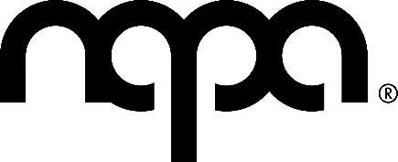
Sarah Stone
Junior Musical Theatre Teacher

