Tuesday 13th September 2022

Dear Parents/Students

As you are aware your child will be appearing in a production of SpongeBob the Musical this academic year, unfortunately due to the nature and difficulty of the show we may need some of the students to play their roles across more than one class.

Please note students would only have to attend their usual lessons, until closer to the show dates when they may be asked to attend a rehearsal. Students would be required to attend the entire weekend of performances and dress rehearsals. (No additional fee)

Please tick the boxes of the performances your child can attend and return by your child’s class on the week commencing Monday 26th September.

Tuesday Inters – 6.00pm-7.30pm
Thursday 27th April– Dress rehearsal 5.00pm – 9.00pm (£5)
Friday 28th April – Show – 7.00pm
Saturday 29th – Show – 7.00pm

Wednesday Inters – 5.00pm-6.30pm
Thursday 4th May– Dress rehearsal 5.00pm – 9.00pm (£5)
Friday 5th May – Show – 7.00pm
Saturday 6th May – Show – 7.00pm

Saturday Inters – 11.00.am – 12.30pm
Thursday 11th May– Dress rehearsal 5.00pm – 9.00pm (£5)
Friday 12th May – Show – 7.00pm
Saturday 13th May – Show – 7.00pm
Auditions will take place the week commencing Monday 26th September, these auditions will take place during student’s usual class time.
Many thanks for your support; any queries please feel free to contact me.

Paddy Start
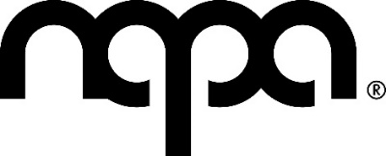
Head of Musical Theatre & Outreach
Patrick.start@northernacademy.org.uk
01482 310690 (ext.3)

