Tuesday 18th October 2022

Dear Parent/Students,

This is a letter to make you aware of the show dates and extra rehearsals for 'The Twits 'which will be performed in our theatre.

Show Week
Thursday 2nd February 2023- Dress Rehearsal - Spm-8pm (£5) Friday 3rd February 2023- @7pm
Saturday 4th February 2023 - @7pm

All children will be required to be at NAPA 1 hour before the production.
Please note if you are missing from the dress rehearsal you will not be allowed to do the show.

There will be two extra rehearsals for this show:
Saturday 12th November -1.30pm-5pm (£5) Saturday 28th January - 1.30pm-5pm (£5)

If you cannot make either of these rehearsals, please let me know as soon as possible. ·

Many Thanks, Jenny Walters
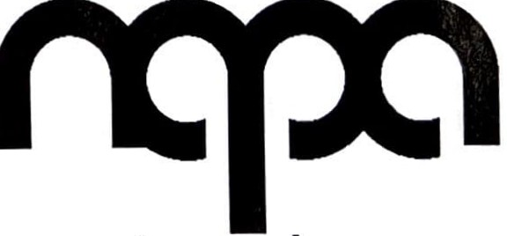
Email: Jenny.walters@northernacademy.i1rg.uk

the northern academy of performing art

