Tuesday 14th March 2023

Dear Parent/Students,

This is a letter to make you aware of the show dates and extra rehearsals for ‘ A Monster Calls' which will be performed in our theatre.

Show Week
Thursday 15th June 2023- Dress Rehearsal - 5pm-8pm (£5)
Friday 16th June 2023-7pm
Saturday 17th June 2023 -7pm

All students will be required to be at NAPA 1 hour before the production.
Please note if you are missing from the dress rehearsal you will not be allowed to do the show.

There will be two extra rehearsals for this show:
Saturday 20th May -1.30pm-6pm (£5)
Saturday 10th June -1.30pm-6pm (£5)

If you cannot make either of these rehearsals, please let me know as soon as possible. ·

Many Thanks, Jenny Walters
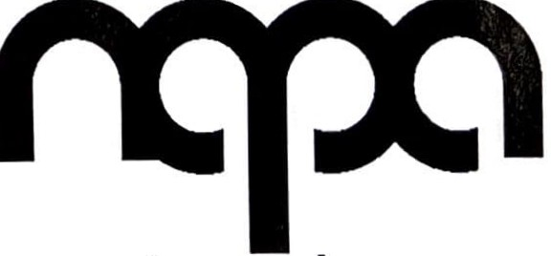
Email: Jenny.walters@northernacademy.org.uk

the northern academy of performing arts

