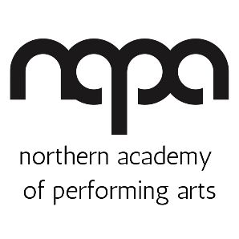
CASTING POLICY
NAPA’s approach to casting shows
This policy will be reviewed on an ongoing basis, at least once a year. NAPA will amend this policy, following consultation, where appropriate.
Date of last review: 21/03/2022
NAPA is committed to promoting the performing arts as an activity for all. We are committed to eliminating discrimination and encouraging diversity across all areas of our work.

- We aim to present to our audiences theatrical work of the highest possible standard and casting is crucial to achieving that aim.
- Our creative team always strives to cast students in the roles to which they are best suited for a particular production providing them with an opportunity to develop personally and artistically.
- The guiding objective is always to assemble the overall cast that will best serve the directorial vision for the show.
- All productions at NAPA will be cast through an open audition process, except in the case of the very youngest students where the teacher will decide who plays which part.
- Auditions will always be free at NAPA.
- We pledge to provide equality and fairness for all in casting and not discriminate on grounds of gender and gender reassignment, race, disability, sexual orientation, religion or age.
- Auditions at NAPA are open to all students who attend classes. We will always do our best to see an individual for audition if they can’t make the advertised dates.
- Auditions for our main external production of the year are open to anyone, regardless of previous attendance at NAPA.
- We want all students to be amazing in auditions and so will create an environment which allows auditionees to relax and give their best audition.
- The director’s decision on casting is final.
- Auditions will comply with NAPA’s Equality and Diversity Policy.
With casting at NAPA, we wish to ensure opportunities are given to all of our students, from all walks of life. We are actively seeking greater inclusivity and accessibility within our student base and casting.

