OPEN AUDITIONS

Frozen jr.

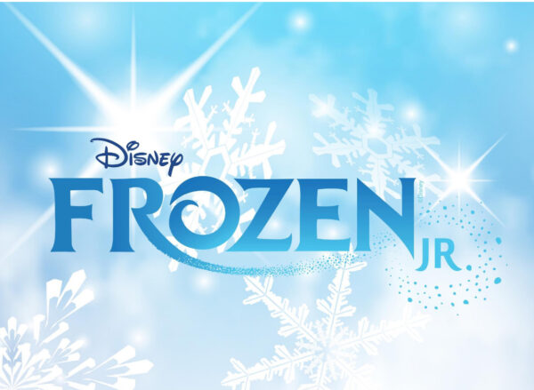

The Northern Academy of Performing Arts in Hull is offering young performers the amazing opportunity to star in a production of this Children’s Musical at Napa in January 2024,

Auditions
- Thursday 7th September 2023 – 5pm till 8pm at NAPA
- Ages 7 – 14 years
- Sing the vocal selection of the role you are auditioning for. (See website for copies)

Audition Material:
Let it go (Bar 52 – End) – All Female Roles
In Summer (Bar 6 – 23) – All Male Roles

Rehearsals:
The rehearsals will be on Saturdays from 9.30am – 10.30am, costing £6.00 per lesson.
Starting Saturday 9th September – (Additional rehearsals may be scheduled with prior notice.)
Please only audition if you are available at this time.

Show Week:
Thursday 25th January 2024– Dress Rehearsal – 5pm-8pm
Friday 26th January 2024- @7pm
Saturday 27th January 2024 - @7pm
Sunday 28th January 2024 - @ 2pm

For any more information and to register your interest please contact
Paddy Start - Telephone: 01482 310690 (ext.3)
Email: Patrick.start@northernacademy.org.uk
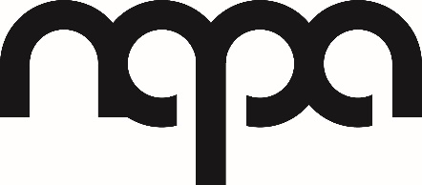
The Northern Academy or Performing Arts
Anlaby Road, Hull, HU1 2PD www.northernacademy.org.uk

