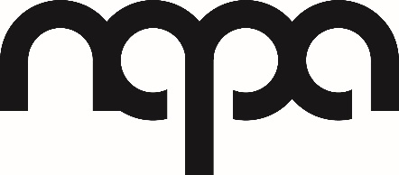

AUDITIONS
Edward Scissor Hands

The Northern Academy of Performing Arts in Hull is offering performers the amazing opportunity to star in an Acting production of Edward Scissorhands at NAPA in February 2024. Participation in this performance is subject to a successful audition.

Auditions – Auditions will take place in the form of a workshop.
- Tuesday 12th September 2023 – 7.30pm – 9pm in F4
- Ages 12– 22 years

Rehearsals: Successful students will be required for the following rehearsals.
The rehearsals will be on Tuesday’s 7.30 pm – 9pm, costing £6.50 per lesson starting Tuesday 19th February 2023 – (Additional rehearsals will be scheduled with prior notice.)
Please only audition if you are available at these times.

Show Week:
Thursday 8th^{th} February 2024-@ 5-8pm- Dress Rehearsal (£5)
Performances:
Friday 9th February 2024- @7pm
Saturday 10th February 2024- @7pm
For any more information please contact
Jenny Walters
Email: Jenny.walters@northernacademy.org.uk

