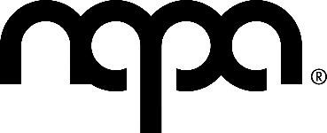

Emergence Workshop Filming

07.12.23
Dear Emergence Student / Parent

As you will be aware, the Emergence dance class has been invited to take part in a workshop hosted by All England Dance on Thursday 7th December 2023.

During the workshop, All England Dance has requested the session be filmed for promotional use. Please indicate below if you agree to be filmed and distributed by the All- England Dance company. Please note, if you are under 18 you will need a parent or guardian to consent below on behalf of you. Please return this letter to the ground floor admin office or via email no later than Wednesday 6th December 2023.

Please note that The Northern Academy of Performing Arts will not have any control over the distribution of the videos, and this filming is in no way affiliated with NAPA.

Please also note that the timings of the workshop have changed slightly, the workshop will now run between 5pm-7pm.

If you have any questions or concerns, please contact us as soon as possible by emailing napa@northernacademy.org.uk or by calling 01482 310690 (extension 1).
Kind Regards, Charlie Soper
Admin Assistant

Please circle below to indicate your response.

I GIVE or DO NOT GIVE consent for myself (or my child) to be filmed for promotional use on 07.12.23 by All England Dance and the footage to be distributed freely.

Date: Name: Sign:

