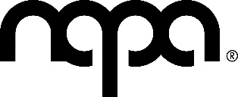

𝗔𝗨𝗗𝗜𝗧𝗜𝗢𝗡𝗦: 𝗜𝗡𝗧𝗘𝗥𝗠𝗘𝗗𝗜𝗔𝗧𝗘 𝗔𝗡𝗗 𝗦𝗘𝗡𝗜𝗢𝗥 𝗔𝗖𝗧𝗜𝗡𝗚 𝗣𝗥𝗢𝗗𝗨𝗖𝗧𝗜𝗢𝗡
We're offering NAPA's young actors the chance to take part in a production of Night of the Living Dead at the NAPA Theatre in June 2025.
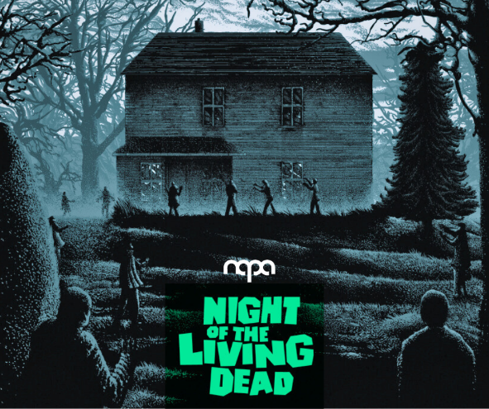
𝘼 𝙜𝙧𝙤𝙪𝙥 𝙤𝙛 𝙨𝙩𝙧𝙖𝙣𝙜𝙚𝙧𝙨 𝙩𝙧𝙖𝙥𝙥𝙚𝙙 𝙞𝙣 𝙖 𝙧𝙪𝙧𝙖𝙡 𝙛𝙖𝙧𝙢𝙝𝙤𝙪𝙨𝙚 𝙛𝙞𝙜𝙝𝙩 𝙛𝙤𝙧 𝙩𝙝𝙚𝙞𝙧 𝙡𝙞𝙫𝙚𝙨 𝙖𝙜𝙖𝙞𝙣𝙨𝙩 𝙖𝙣 𝙖𝙧𝙢𝙮 𝙤𝙛 𝙜𝙝𝙤𝙪𝙡𝙨 𝙤𝙪𝙩𝙨𝙞𝙙𝙚 𝙧𝙚𝙡𝙮𝙞𝙣𝙜 𝙤𝙣 𝙫𝙖𝙜𝙪𝙚 𝙣𝙚𝙬𝙨 𝙧𝙚𝙥𝙤𝙧𝙩𝙨 𝙖𝙣𝙙 𝙛𝙞𝙡𝙩𝙚𝙧𝙞𝙣𝙜 𝙝𝙤𝙥𝙚𝙨 𝙤𝙛 𝙧𝙚𝙨𝙘𝙪𝙚. 𝙏𝙝𝙚 𝙜𝙧𝙤𝙪𝙥 𝙩𝙧𝙞𝙚𝙨 𝙩𝙤 𝙤𝙫𝙚𝙧𝙘𝙤𝙢𝙚 𝙙𝙞𝙛𝙛𝙚𝙧𝙚𝙣𝙘𝙚𝙨 𝙞𝙣 𝙤𝙥𝙞𝙣𝙞𝙤𝙣𝙨 𝙞𝙣 𝙖𝙣 𝙚𝙛𝙛𝙤𝙧𝙩 𝙩𝙤 𝙬𝙤𝙧𝙠 𝙩𝙤𝙜𝙚𝙩𝙝𝙚𝙧 𝙩𝙤 𝙨𝙪𝙧𝙫𝙞𝙫𝙚!
𝙉𝙞𝙜𝙝𝙩 𝙤𝙛 𝙡𝙞𝙫𝙞𝙣𝙜 𝙙𝙚𝙖𝙙 𝙬𝙞𝙡𝙡 𝙝𝙖𝙫𝙚 𝙮𝙤𝙪 𝙘𝙡𝙚𝙣𝙘𝙝𝙞𝙣𝙜 𝙩𝙝𝙚 𝙚𝙙𝙜𝙚 𝙤𝙛 𝙮𝙤𝙪𝙧 𝙨𝙚𝙖𝙩𝙨 𝙨𝙦𝙪𝙞𝙣𝙩𝙞𝙣𝙜 𝙞𝙣𝙩𝙤 𝙩𝙝𝙚 𝙙𝙖𝙧𝙠𝙣𝙚𝙨𝙨 𝙩𝙤 𝙨𝙚𝙚 𝙞𝙛 𝙖 𝙯𝙤𝙢𝙗𝙞𝙚 𝙞𝙨 𝙡𝙪𝙢𝙗𝙚𝙧𝙞𝙣𝙜 𝙞𝙣 𝙮𝙤𝙪𝙧 𝙙𝙞𝙧𝙚𝙘𝙩𝙞𝙤𝙣.
Auditions are open to NAPA acting students ages 14-18.
𝗔𝗨𝗗𝗜𝗧𝗜𝗢𝗡𝗦
Wednesday 26th March 7.30-8.30pm
The auditions will take the form of a workshop, there is nothing to prepare in advance
𝗥𝗘𝗛𝗘𝗔𝗥𝗦𝗔𝗟𝗦
Wednesdays 7.30-9pm (£7.50 per class) commencing 2nd April 2025
Dress Rehearsal - Thursday 19th June 5-8pm
𝗣𝗘𝗥𝗙𝗢𝗥𝗠𝗔𝗡𝗖𝗘𝗦
Saturday 21st June at 7pm
Sunday 22nd June at 7pm
Please only attend the audition if you are available for the rehearsal and performance dates mentioned above.
Many thanks,
Jenny Walters
If you have any queries, please email jenny.walters@northernacademy.org.uk

