20/10/2025
Northern Stars 2026
Middleton Hall - University of Hull

Dear Parents,
Please find below some important information regarding our annual dance show coming up in Feb 26. (We are VERY excited !)

This show will include all students who take any Ballet, Tap or Modern classes, unless you inform us in advance that you do not wish your child to take part (see below for details).

Dress Rehearsal
Saturday 7th February – Middleton Hall (More info and times will be provided nearer the date).

Shows
Sunday 8th February – 12.00pm & 4.00pm - Middleton Hall

Tickets
A link to the ticket booking site will be sent via email in advance
On sale from: Monday 10th November 2025 - 12.00pm
Price: £14

Production Fee
£60 per student
£35 per student if only taking 1 class

If you do not wish your child to take part
If you do not wish your child to take part the performance, please let us know by completing the short online form. Following the link below, or via the QR code.
We need to know by the latest Monday 10th November as we are starting to order costumes and set choreography for numbers.
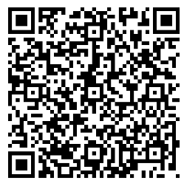
https://forms.office.com/e/ffbYfUqki9

If you have any questions or concerns, please get in touch with us.

Julie Lovewell, Head of Dance, will also be available to speak to in person if you want to discuss anything show/class related, on Sat 8th November.

Best Wishes

NAPA Dance Department
dance@northernacademy.org.uk
Tel: 01482 310690

